Substantive comments
My main comment is about the matching process you use, and how it relates to your theoretical argument. I buy your theory that, all else equal, poor communities in wealthier fiscal units will have better social mobility outcomes (your H2). However, since you are matching communities only on poverty rate and education rate, I’m not sure you’re providing us with the strongest possible empirical test of this hypothesis, since there are so many other space-varying factors that affect social mobility. Specifically, I would think that what matters for social mobility outcomes is not just the level of wealth of one’s fiscal unit, but also the extent to which that wealth gets taxed and how the government spends that tax revenue. To that end, I wonder if you could either 1) make within-state comparisons to control for state-level political factors, and/or 2) obtain data on state- or local-government ideology and match communities on this variable as well as poverty and education (I know data on state-government ideology exist; not sure about local ideology off the top of my head). I wonder if this might also help with the very low R-squared in the regression models you report, as well as the puzzling difference in the results for personal income rank vs. household income rank.
Relatedly, I would love to see you theorize more about where/when fiscal unit wealth matters for social mobility, and where/when it does not. I would imagine that government ideology plays a big role in this, as I’ve mentioned above. But beyond ideology or partisanship, perhaps during times of austerity, fiscal unit wealth doesn’t play such a big role, since governments aren’t spending as much on the public goods and services that contribute to upward mobility and are financed in large part through tax revenue generated at the fiscal unit level. Adding these dimensions to your theory and empirics would have the added bonus of making the argument more grounded in political science than economics.

Coding/Replication comments
- There is something not quite right about the code to produce the coefficient plot (Figure 2 in the partial draft)—the code runs without throwing an error, but the plot it produces only contains the coefficient for KFR, age 26. I don’t observe this issue when replicating your regression tables.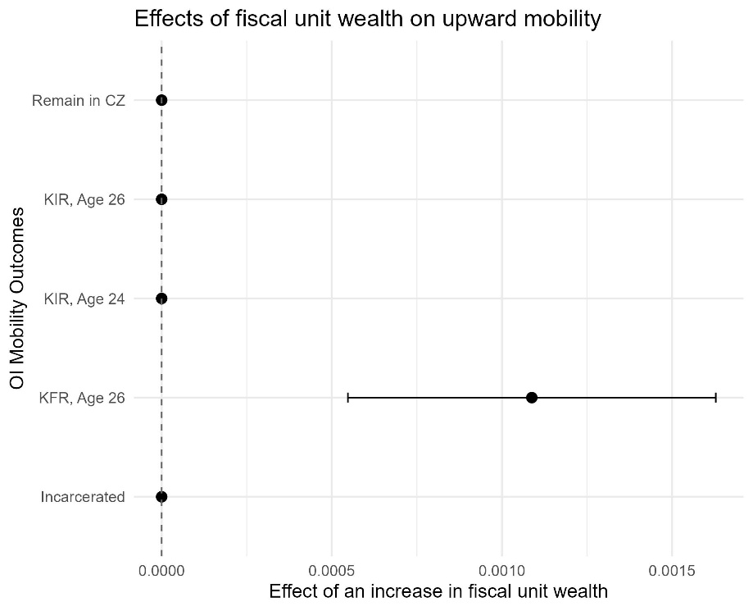
- Line 439 is throwing the following error and warning: “Error: SyntaxError: Unexpected token . In addition: Warning message: In ms_de_unit(input) : Coercing these 'units' columns to class numeric: overlap_area
- It would be helpful to add more comments to your code explaining what is being done and why. (Perhaps if I knew more about matching and using shapefiles this would not be an issue, but I sometimes found myself struggling to understand exactly what was going on in the code despite being familiar with R.)

